Use this reference to complete continuing student onboarding.

You will receive Continuing Student Onboarding action items in your Workday Inbox at the beginning of each academic period. These are required action items. Failure to complete onboarding will prevent you from registering for classes.

As part of the onboarding process, you will:
- Review Documents
- Consent to Receive Form 1098-T Electronically
- Review My Friends and Family
- Review My Home Contact Information
- Review My Personal Information
- Make My Federal Student Aid Authorizations

If you need to complete onboarding a message will appear on the Academics app homepage.

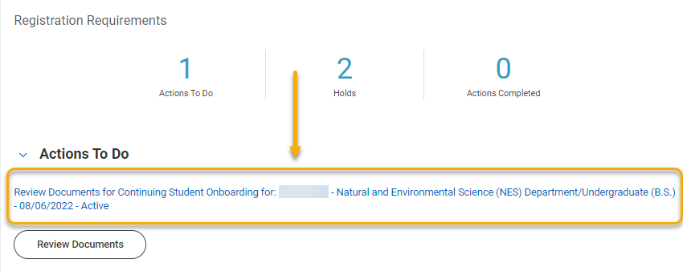

How to Complete Continuing Student Onboarding

- Log into Workday. Click My Tasks, the envelope at the top of the screen. An indicator will show unread messages.



- From the sidebar, select the Continuing Student Onboarding item.

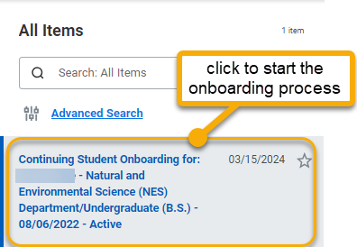

- Various onboarding action items will appear. Each item has a different set of actions to take. Read through each action carefully.

- The first item is “Review Documents”. Review the documents, click “I Agree” and click “Submit”.

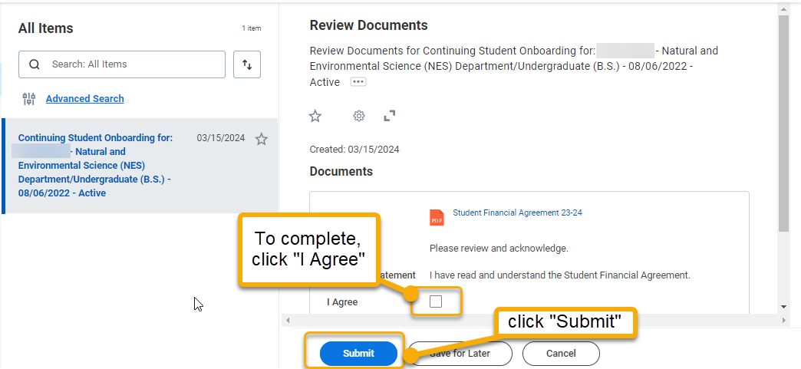

- The You Have Submitted window will appear to confirm the action. This window will also introduce the next action item. Click “Open”.

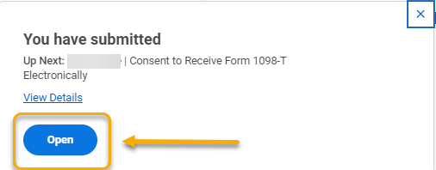

- The Consent to Receive Form 1098-T Electronically item will appear. Review, check the box and click “Submit”.

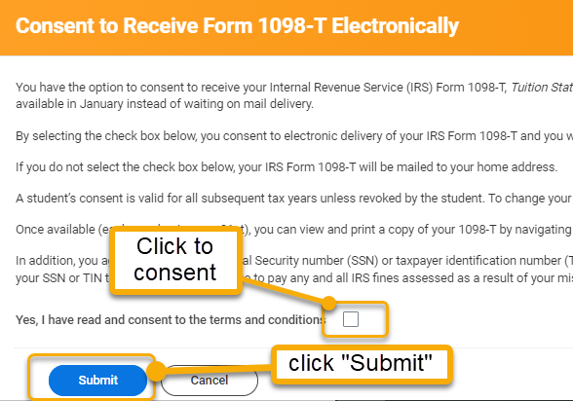

- Click “Done”.



- You will automatically return to My Tasks and four new action items will appear. Begin completing each item by following the directions below.

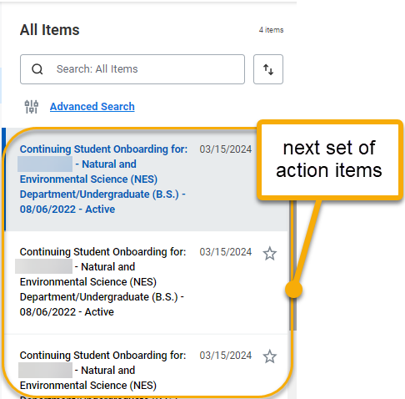

- The first item is Review My Friends and Family. Review to ensure you have at least one emergency contact. To add a new contact, click “Add”. To edit or delete existing contacts, scroll to the right and click “Actions”. See the end of this guide for instructions on adding a contact.

When finished, click “Submit”.

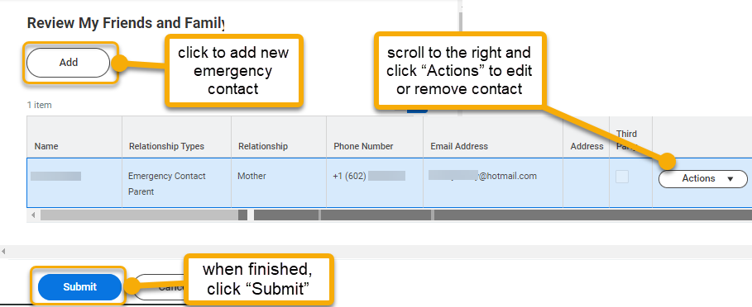

- Click “Done”.



- The next item is Review My Home Contact Information. Review your address, phone number, and email address. To make changes, click “Edit”. When finished, click “Approve”.

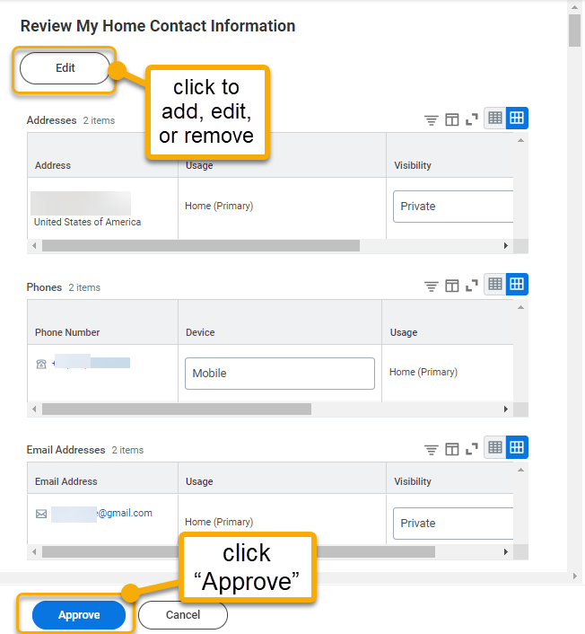

- The Success! Event approved window will appear to confirm the action. This window will also introduce the next action item. Click “Review Documents”.

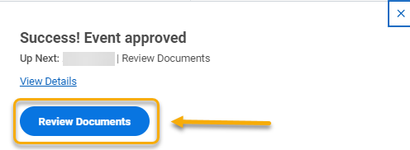

- The Review Documents page will appear. Click “I Agree” and click “Submit”.

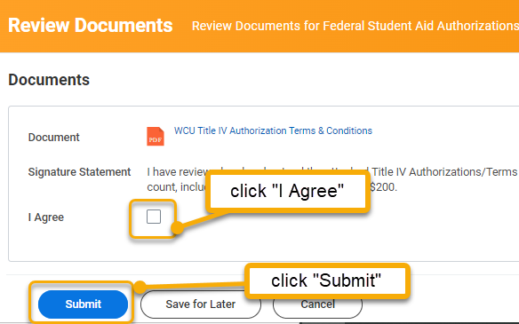

- The You Have Submitted window will appear to confirm the action and introduce the next step. Click “Open”.

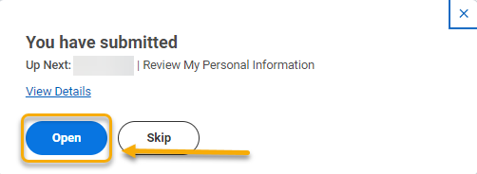

- On the Review My Personal Information page, click the “Edit” button to make changes. Otherwise, click “Approve”.

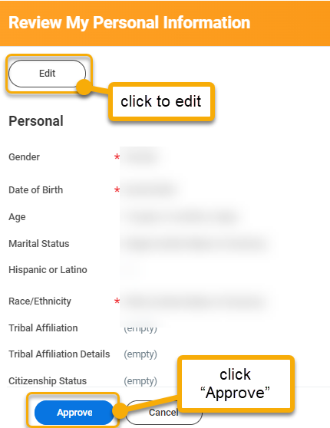

- The You Have Submitted window will appear to confirm the action. Click “Review”.

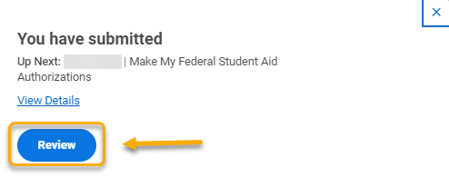

- On the Make My Federal Student Aid Authorizations page, make sure the I Authorize box is checked. Click “Submit”.

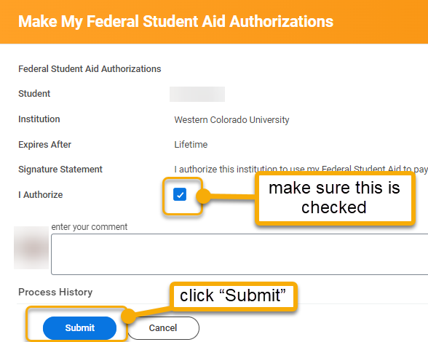

- The Success! Event Submitted window will appear. Congratulations! You’ve finished the onboarding process!



TIPS for REVIEWING FRIENDS AND FAMILY

In the Friends and Family action, you are asked to identify an emergency contact and parent. There are few things to highlight about this step.

- Click “Add” button to add a person.
- Designate at least one person as “Emergency Contact”.
- Each contact must have a Phone Number and Email.
- To delete or edit a contact, click Actions to reveal a drop-down menu and follow the instructions.

